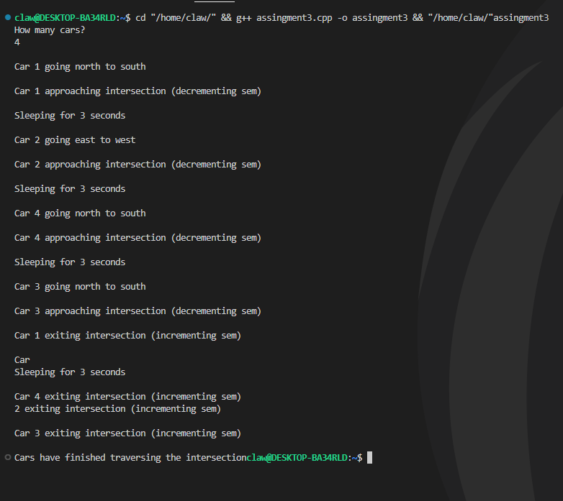

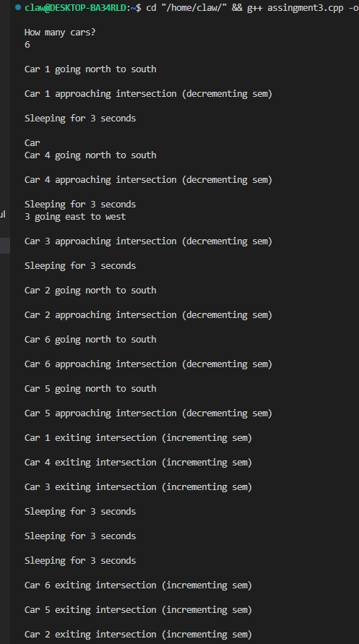

#include <iostream>

#include <string>

#include <pthread.h>

#include <semaphore.h>

#include <unistd.h>

#include <time.h>

using namespace std;

sem_t x;

void *teentalwar(void *arg)

{

    int val = rand() % 2;

    if (val == 0)

    {

        cout << "\nCar " << (intptr_t)(arg) << " going east to west\n";

    }

    else if (val == 1)

    {

        cout << "\nCar " << (intptr_t)(arg) << " going north to south\n";

    }

    cout << "\nCar " << (intptr_t)(arg) << " approaching intersection (decrementing sem)\n";

    sem_wait(&x); // acquired

    cout << "\nSleeping for 3 seconds\n";

    sleep(3);

    cout << "\nCar " << (intptr_t)(arg) << " exiting intersection (incrementing sem)\n";

    sem_post(&x); // release

    return nullptr;

}

int main()

{

    cout << "How many cars?\n";

    int cars;

    cin >> cars;

    pthread_t c[cars];

    sem_init(&x, 0, 3);

    for (int i = 0; i < cars; i++)

    {

        pthread_create(&c[i], NULL, teentalwar, (void *)(intptr_t)(i + 1));

    }

    sleep(1);

    for (int i = 0; i < cars; i++)

    {

        pthread_join(c[i], NULL);

    }

    cout << "\nCars have finished traversing the intersection";

    return 0;

};